CRYPTOGRAPHY & NETWORK SECURITY LAB
III Year - II Semester
Lecture: 3 Internal Marks: 30
Credits: 1.5 External Marks: 70
Course Objectives
- To learn basic understanding of cryptography, how it has evolved, and some key encryption techniques used today.
- To understand and implement encryption and decryption using Ceaser Cipher, Substitution Cipher, Hill Cipher.

Course Outcomes:
Upon successful completion of the course, the students will be able to
- perform bitwise logical operations on given data to scrable the data.
- demonstrate the basic substitution and transformation ciphers on plain text.
- implement block cipher algorithms to secure the data.
- develop Public key crypto system to Secure and authenticate the data.

List of Experiments:
- Write a C program that contains a string (char pointer) with a value \Hello World’. The program should XOR each character in this string with 0 and displays the result.
Description:
Every character in C is stored as a binary value (ASCII code).
For example, the letter 'A' has ASCII 65, which is:
'A' = 65 = 01000001 (in 8-bit binary)
We can apply bitwise operations:
- AND (&) → keeps bits that are 1 in both operands
- OR (|) → keeps bits that are 1 in any operand
- XOR (^) → keeps bits that are 1 only in one operand, not both

The XOR operation has a special rule:
Any value XOR 0 gives the same value.
(Because XOR only flips bits when the second operand has 1s, and 0 has no 1s)
So:
- 'H' ^ 0 → 'H'
- 'e' ^ 0 → 'e'
- … and so on
Procedure:
- Contains a string with the value "Hello World".
- The string should be stored using a char pointer.
Example: char *str = "Hello World";
- The program must take each character in the string and perform an XOR operation with the value 0.
That is: new_char = old_char ^ 0
- Finally, the program should display the result of applying XOR with 0 to every character.
Program:
int main() {
char *str;
int i;

// Allocate memory for input string
str = (char *)malloc(100 * sizeof(char));

printf("Enter a string: ");
scanf("%[^\n]s", str); // take input with scanf (reads until newline)

printf("Result after XOR with 0: ");

for (i = 0; str[i] != '\0'; i++) {
char result = str[i] ^ 0; // XOR with 0
printf("%c", result);
}

free(str);
return 0;
}
Output:
Enter a string:
hello welcome to CSE
Result after XOR with 0: hello welcome to CSE

- Write a C program that contains a string (char pointer) with a value \Hello World’. The program should AND or and XOR each character in this string with 127 and display the result
Procedure:
- Have a string using a char pointer, e.g., "Hello World".
- For each character, perform bitwise operations:
  - AND with 127 → ch & 127
  - XOR with 127 → ch ^ 127
- Display the results of these operations.
Note: 127 in binary is 01111111 (7 bits).
- AND keeps only the lower 7 bits of the character.
- XOR flips the bits wherever there is 1 in 127.

AND each character with 127
  - binary = 01111111

Formula: result = str[i] & 127
Character | Binary | AND 127 | Result (Binary) | Result
H | 01001000 | 01001000 | 01001000 | H
e | 01100101 | 01100101 | 01100101 | e
l | 01101100 | 01101100 | 01101100 | l
l | 01101100 | 01101100 | 01101100 | l
o | 01101111 | 01101111 | 01101111 | o

XOR each character with 127
127 in binary = 01111111

Formula: result = str[i] ^ 127
Character | Binary | XOR 127 | Result (Binary) | Result (ASCII) | Result (Char)
H | 01001000 | 00110111 | 00110111 | 55 | 7
e | 01100101 | 00011010 | 00011010 | 26 | Non-printable
l | 01101100 | 00010011 | 00010011 | 19 | Non-printable
l | 01101100 | 00010011 | 00010011 | 19 | Non-printable
o | 01101111 | 00010000 | 00010000 | 16 | Non-printable

#include <stdio.h>
#include <stdlib.h>

int main() {
char *str;
int i;
str = (char *)malloc(100 * sizeof(char)); // Allocate memory for user input

printf("Enter a string: ");
scanf("%[^\n]s", str); // Take input including spaces

printf("\nOriginal string: %s\n", str);

// AND operation with 127
printf("After AND with 127: ");
for (i = 0; str[i] != '\0'; i++) {
printf("%c", str[i] & 127);
}
// XOR operation with 127
printf("\nAfter XOR with 127: ");
for (i = 0; str[i] != '\0'; i++) {
printf("%c", str[i] ^ 127);
}

free(str); // Free allocated memory
return 0;
}
Input & Output:
(i). Enter a string: hai CSE how are you

Original string: hai CSE how are you
After AND with 127: hai CSE how are you
After XOR with 127: -_<,:__-
(ii). Enter a string: Hello World

Original string: Hello World
After AND with 127: Hello World
After XOR with 127:  '

- Write a Java program to perform encryption and decryption using the following algorithms:
  - Ceaser Cipher b) Substitution Cipher c) Hill Cipher

Translation ciphers, often referred to as substitution ciphers, are a type of cipher where each letter in the plaintext is replaced with another letter.

Caesar Cipher
A Caesar cipher shifts every letter of the plaintext by a fixed number of positions in the alphabet.
Caesar Cipher

- A simple monoalphabetic cipher.
- Each letter in plaintext is shifted by a fixed number of positions.
- Example (shift = 3):
HELLO → KHOOR

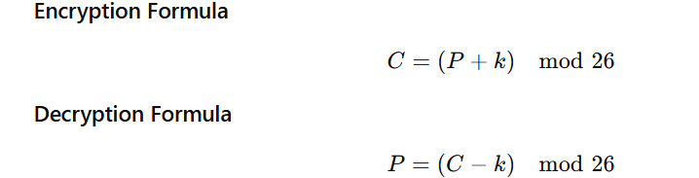
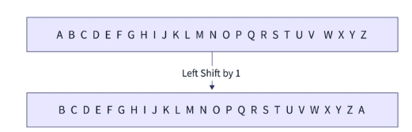
Plain Text : ATTACKATONCE
Shift: 4
Cipher Text: EXXEGOEXSRGI

- Despite its simplicity, the Caesar Cipher formed the groundwork for modern cryptographic techniques.

Program:
import java.util.Scanner;

public class CaesarCipher {

static String encrypt(String text, int shift) {
StringBuilder result = new StringBuilder();
for (char c : text.toCharArray()) {
if (Character.isLetter(c)) {
char base = Character.isUpperCase(c) ? 'A' : 'a';
result.append((char) ((c - base + shift) % 26 + base));
} else {
result.append(c);
}
}
return result.toString();
}

static String decrypt(String text, int shift) {
return encrypt(text, 26 - shift);
}

public static void main(String[] args) {
Scanner sc = new Scanner(System.in);
System.out.print("Enter text: ");
String text = sc.nextLine();
System.out.print("Enter shift key: ");
int shift = sc.nextInt();

String encrypted = encrypt(text, shift);
String decrypted = decrypt(encrypted, shift);

System.out.println("Encrypted Text: " + encrypted);
System.out.println("Decrypted Text: " + decrypted);
sc.close();
}
}
Input & Output:
Enter text: HELLO WORLD
Enter shift key: 3
Encrypted Text: KHOOR ZRUOG
Decrypted Text: HELLO WORLD

- Substitution Cipher

Every letter in the plaintext is replaced with another fixed letter according to a substitution key alphabet.
Let the substitution key be:
Plain: ABCDEFGHIJKLMNOPQRSTUVWXYZ
Cipher: QWERTYUIOPASDFGHJKLZXCVBNM

Encryption
C → E
A → Q
T → Z

import java.util.Scanner;

public class SubstitutionCipher {

static String encrypt(String text, String key) {
StringBuilder result = new StringBuilder();
String alphabet = "ABCDEFGHIJKLMNOPQRSTUVWXYZ";
text = text.toUpperCase();
key = key.toUpperCase();

for (char c : text.toCharArray()) {
if (Character.isLetter(c)) {
int index = alphabet.indexOf(c);
result.append(key.charAt(index));
} else {
result.append(c);
}
}
return result.toString();
}

static String decrypt(String text, String key) {
StringBuilder result = new StringBuilder();
String alphabet = "ABCDEFGHIJKLMNOPQRSTUVWXYZ";
text = text.toUpperCase();
key = key.toUpperCase();

for (char c : text.toCharArray()) {
if (Character.isLetter(c)) {
int index = key.indexOf(c);
result.append(alphabet.charAt(index));
} else {
result.append(c);
}
}
return result.toString();
}

public static void main(String[] args) {
Scanner sc = new Scanner(System.in);
System.out.print("Enter text: ");
String text = sc.nextLine();
System.out.print("Enter 26-letter key: ");
String key = sc.nextLine();

String encrypted = encrypt(text, key);
String decrypted = decrypt(encrypted, key);

System.out.println("Encrypted Text: " + encrypted);
System.out.println("Decrypted Text: " + decrypted);
sc.close();
}
}
Input & Output:
Enter text: HELLO
Enter 26-letter key: QWERTYUIOPASDFGHJKLZXCVBNM
Encrypted Text: ITSSG
Decrypted Text: HELLO

C). Hill Cipher (2×2 matrix)

A Hill cipher uses matrix multiplication (mod 26).
Plaintext letters are converted to numbers (A=0, B=1, … Z=25)
Program:
import java.util.Scanner;

public class HillCipher {

static int[][] keyMatrix = {{3, 3}, {2, 5}}; // 2x2 key matrix

static String encrypt(String text) {
text = text.toUpperCase();
if (text.length() % 2 != 0) text += "X"; // padding

StringBuilder cipherText = new StringBuilder();
for (int i = 0; i < text.length(); i += 2) {
int x1 = text.charAt(i) - 'A';
int x2 = text.charAt(i + 1) - 'A';
int y1 = (keyMatrix[0][0] * x1 + keyMatrix[0][1] * x2) % 26;
int y2 = (keyMatrix[1][0] * x1 + keyMatrix[1][1] * x2) % 26;
cipherText.append((char) (y1 + 'A'));
cipherText.append((char) (y2 + 'A'));
}
return cipherText.toString();
}

static int modInverse(int a, int m) {
a = a % m;
for (int x = 1; x < m; x++)
if ((a * x) % m == 1)
return x;
return 1;
}

static String decrypt(String text) {
int det = keyMatrix[0][0] * keyMatrix[1][1] - keyMatrix[0][1] * keyMatrix[1][0];
det = ((det % 26) + 26) % 26;
int detInv = modInverse(det, 26);

int[][] invKey = new int[2][2];
invKey[0][0] = (keyMatrix[1][1] * detInv) % 26;
invKey[0][1] = ((-keyMatrix[0][1] + 26) * detInv) % 26;
invKey[1][0] = ((-keyMatrix[1][0] + 26) * detInv) % 26;
invKey[1][1] = (keyMatrix[0][0] * detInv) % 26;

StringBuilder plainText = new StringBuilder();
for (int i = 0; i < text.length(); i += 2) {
int y1 = text.charAt(i) - 'A';
int y2 = text.charAt(i + 1) - 'A';
int x1 = (invKey[0][0] * y1 + invKey[0][1] * y2) % 26;
int x2 = (invKey[1][0] * y1 + invKey[1][1] * y2) % 26;
plainText.append((char) (x1 + 'A'));
plainText.append((char) (x2 + 'A'));
}
return plainText.toString();
}

public static void main(String[] args) {
Scanner sc = new Scanner(System.in);
System.out.print("Enter text (letters only): ");
String text = sc.nextLine();

String encrypted = encrypt(text);
String decrypted = decrypt(encrypted);

System.out.println("Encrypted Text: " + encrypted);
System.out.println("Decrypted Text: " + decrypted);
sc.close();
}
}
Input & Output:
Enter text (letters only): HELLO
Encrypted Text: EHNLPX
Decrypted Text: HELLOX
- Write a Java program to implement the DES algorithm logic
Java Program: DES Encryption and Decryption:
- DES (Data Encryption Standard)
- DES is symmetric encryption
- Developed by IBM in the 1970s.
- The most widely used encryption scheme is based on the Data Encryption Standard(DES) adopted in 1977 by the National Bureau of Standards, now the National Institute of Standards and Technology (NIST), as Federal Information Processing Standard 46.
- The algorithm itself is referred to as the Data Encryption Algorithm (DEA).
- Block size: 64 bits
- Key size : 64 bits (56 effective bits + 8 parity bits)
- Structure : FEISTEL NETWORK
- Number of rounds : 16
- DES is a symmetric key block cipher.
- Java provides DES through the javax.crypto package.
- KeyGenerator is used to generate a 56-bit DES key.
- Cipher class performs encryption and decryption.
- Encrypted output is encoded using Base64 for readability.
- The same secret key is used for both encryption and decryption.
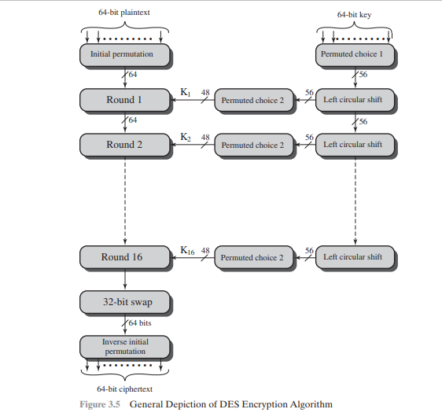
FEISTEL STRUCTURE (CORE OF DES)
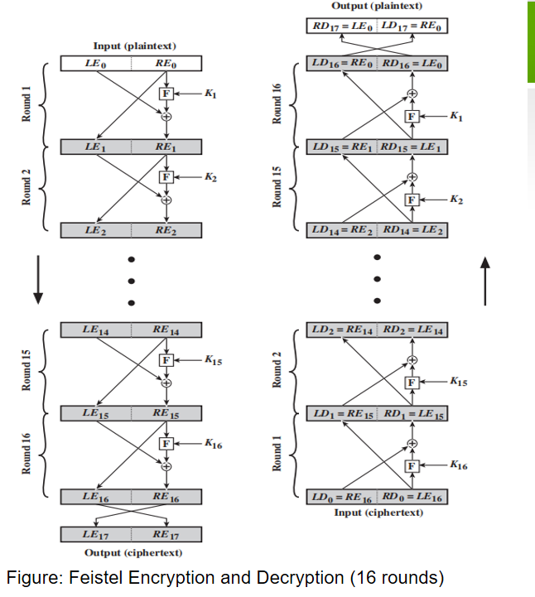
Each round of DES follows the Feistel structure:
Li = Ri-1
Ri = Li-1 ⊕ F(Ri-1, Ki)
Where:
- L and R are left and right halves (32 bits each)
- F is the Feistel (round) function
- Ki is the round subkey

Program:
import javax.crypto.Cipher;
import javax.crypto.KeyGenerator;
import javax.crypto.SecretKey;
import java.util.Base64;
import java.util.Scanner;

public class DESAlgorithm {

public static void main(String[] args) throws Exception {

Scanner sc = new Scanner(System.in);

// Input plaintext
System.out.println("Enter the plaintext:");
String plainText = sc.nextLine();

// Generate DES key
KeyGenerator keyGen = KeyGenerator.getInstance("DES");
SecretKey secretKey = keyGen.generateKey();

// Print generated DES key
String encodedKey = Base64.getEncoder().encodeToString(secretKey.getEncoded());
System.out.println("Generated DES Key: " + encodedKey);

// Create Cipher object
Cipher cipher = Cipher.getInstance("DES");

// Encryption
cipher.init(Cipher.ENCRYPT_MODE, secretKey);
byte[] encryptedBytes = cipher.doFinal(plainText.getBytes());
String encryptedText = Base64.getEncoder().encodeToString(encryptedBytes);

System.out.println("Encrypted Text: " + encryptedText);

// Decryption
cipher.init(Cipher.DECRYPT_MODE, secretKey);
byte[] decryptedBytes = cipher.doFinal(Base64.getDecoder().decode(encryptedText));
String decryptedText = new String(decryptedBytes);

System.out.println("Decrypted Text: " + decryptedText);

sc.close();
}
}
Input & Output:
Enter the plaintext:
CRYPTOGRAPHY

Generated DES Key: L9YtY7Z6pQs=
Encrypted Text: Rk0uY1cFqA5p2g==
Decrypted Text: CRYPTOGRAPHY

- Write a C/JAVA program to implement the BlowFish algorithm logic

Program:
import javax.crypto.Cipher;
import javax.crypto.spec.SecretKeySpec;
import java.util.Base64;
import java.util.Scanner;

public class BlowfishUserInput {

// Method to perform Blowfish Encryption
public static String encrypt(String plaintext, String key) throws Exception {

// Convert user key into Blowfish secret key
SecretKeySpec secretKey = new SecretKeySpec(key.getBytes(), "Blowfish");

// Create Blowfish cipher object
Cipher cipher = Cipher.getInstance("Blowfish");

// Initialize cipher in ENCRYPT mode
cipher.init(Cipher.ENCRYPT_MODE, secretKey);

// Encrypt the plaintext
byte[] encryptedBytes = cipher.doFinal(plaintext.getBytes());

// Convert encrypted bytes to Base64 string
return Base64.getEncoder().encodeToString(encryptedBytes);
}

// Method to perform Blowfish Decryption
public static String decrypt(String ciphertext, String key) throws Exception {

// Convert user key into Blowfish secret key
SecretKeySpec secretKey = new SecretKeySpec(key.getBytes(), "Blowfish");

// Create Blowfish cipher object
Cipher cipher = Cipher.getInstance("Blowfish");

// Initialize cipher in DECRYPT mode
cipher.init(Cipher.DECRYPT_MODE, secretKey);

// Decode Base64 and decrypt ciphertext
byte[] decryptedBytes =
cipher.doFinal(Base64.getDecoder().decode(ciphertext));

// Convert decrypted bytes to plain text
return new String(decryptedBytes);
}

public static void main(String[] args) {

try {
Scanner sc = new Scanner(System.in);

System.out.print("Enter Plain Text: "); // Read plaintext from user
String plaintext = sc.nextLine();

System.out.print("Enter Secret Key: "); // Read secret key from user
String key = sc.nextLine();

String encryptedText = encrypt(plaintext, key); // Encrypt the plain text
System.out.println("\nEncrypted Text: " + encryptedText);

String decryptedText = decrypt(encryptedText, key); // Decrypt the cipher text
System.out.println("Decrypted Text: " + decryptedText);

sc.close(); // Close scanner

} catch (Exception e) {
System.out.println("Error: " + e.getMessage());
}
}
}

Input &Output:
Enter Plain Text: this is Cyptograpgy and Network Security lab Blowfish
Enter Secret Key: Feistel structure

Encrypted Text: rbrMqKWI6THrqxYQ4UEfVAT8DB77vGxWRrM5J+noZh5xQOJBCtxrzyVCB0I+9iX1NNuLXOJG3g=
Decrypted Text: this is Cyptograpgy and Network Security lab Blowfish

C Program
#include <stdio.h>
#include <string.h>
#include <openssl/blowfish.h>

int main() {
BF_KEY key; // Blowfish key structure
unsigned char plaintext[64];
unsigned char ciphertext[64];
unsigned char decrypted[64];
unsigned char userkey[32];

// Read plaintext from user
printf("Enter Plain Text: ");
fgets((char *)plaintext, sizeof(plaintext), stdin);

// Read secret key from user
printf("Enter Secret Key: ");
fgets((char *)userkey, sizeof(userkey), stdin);

// Remove newline characters
plaintext[strcspn((char *)plaintext, "\n")] = 0;
userkey[strcspn((char *)userkey, "\n")] = 0;

// Initialize Blowfish key
BF_set_key(&key, strlen((char *)userkey), userkey);

// Encrypt plaintext (8 bytes at a time)
BF_ecb_encrypt(plaintext, ciphertext, &key, BF_ENCRYPT);

printf("\nEncrypted Text: ");
for (int i = 0; i < 8; i++)
printf("%02X ", ciphertext[i]);

// Decrypt ciphertext
BF_ecb_encrypt(ciphertext, decrypted, &key, BF_DECRYPT);

decrypted[8] = '\0'; // Null terminate decrypted text

printf("\nDecrypted Text: %s\n", decrypted);

return 0;
}

- Write a C/JAVA program to implement the Rijndael algorithm logic.

import java.util.Scanner;

public class RijndaelAES {

// AES S-Box
static final int[] sBox = {
0x63,0x7C,0x77,0x7B,0xF2,0x6B,0x6F,0xC5,0x30,0x01,0x67,0x2B,0xFE,0xD7,0xAB,0x76,
0xCA,0x82,0xC9,0x7D,0xFA,0x59,0x47,0xF0,0xAD,0xD4,0xA2,0xAF,0x9C,0xA4,0x72,0xC0,
0xB7,0xFD,0x93,0x26,0x36,0x3F,0xF7,0xCC,0x34,0xA5,0xE5,0xF1,0x71,0xD8,0x31,0x15,
0x04,0xC7,0x23,0xC3,0x18,0x96,0x05,0x9A,0x07,0x12,0x80,0xE2,0xEB,0x27,0xB2,0x75,
0x09,0x83,0x2C,0x1A,0x1B,0x6E,0x5A,0xA0,0x52,0x3B,0xD6,0xB3,0x29,0xE3,0x2F,0x84,
0x53,0xD1,0x00,0xED,0x20,0xFC,0xB1,0x5B,0x6A,0xCB,0xBE,0x39,0x4A,0x4C,0x58,0xCF,
0xD0,0xEF,0xAA,0xFB,0x43,0x4D,0x33,0x85,0x45,0xF9,0x02,0x7F,0x50,0x3C,0x9F,0xA8,
0x51,0xA3,0x40,0x8F,0x92,0x9D,0x38,0xF5,0xBC,0xB6,0xDA,0x21,0x10,0xFF,0xF3,0xD2,
0xCD,0x0C,0x13,0xEC,0x5F,0x97,0x44,0x17,0xC4,0xA7,0x7E,0x3D,0x64,0x5D,0x19,0x73,
0x60,0x81,0x4F,0xDC,0x22,0x2A,0x90,0x88,0x46,0xEE,0xB8,0x14,0xDE,0x5E,0x0B,0xDB,
0xE0,0x32,0x3A,0x0A,0x49,0x06,0x24,0x5C,0xC2,0xD3,0xAC,0x62,0x91,0x95,0xE4,0x79,
0xE7,0xC8,0x37,0x6D,0x8D,0xD5,0x4E,0xA9,0x6C,0x56,0xF4,0xEA,0x65,0x7A,0xAE,0x08,
0xBA,0x78,0x25,0x2E,0x1C,0xA6,0xB4,0xC6,0xE8,0xDD,0x74,0x1F,0x4B,0xBD,0x8B,0x8A,
0x70,0x3E,0xB5,0x66,0x48,0x03,0xF6,0x0E,0x61,0x35,0x57,0xB9,0x86,0xC1,0x1D,0x9E,
0xE1,0xF8,0x98,0x11,0x69,0xD9,0x8E,0x94,0x9B,0x1E,0x87,0xE9,0xCE,0x55,0x28,0xDF,
0x8C,0xA1,0x89,0x0D,0xBF,0xE6,0x42,0x68,0x41,0x99,0x2D,0x0F,0xB0,0x54,0xBB,0x16
};

// SubBytes
static void subBytes(byte[][] state) {
for (int i = 0; i < 4; i++)
for (int j = 0; j < 4; j++)
state[i][j] = (byte) sBox[state[i][j] & 0xFF];
}

// ShiftRows
static void shiftRows(byte[][] state) {
for (int i = 1; i < 4; i++) {
byte[] temp = new byte[4];
for (int j = 0; j < 4; j++)
temp[j] = state[i][(j + i) % 4];
state[i] = temp;
}
}

// AddRoundKey
static void addRoundKey(byte[][] state, byte[][] key) {
for (int i = 0; i < 4; i++)
for (int j = 0; j < 4; j++)
state[i][j] ^= key[i][j];
}

static void printState(byte[][] state) {
for (byte[] row : state) {
for (byte b : row)
System.out.printf("%02X ", b);
System.out.println();
}
}

public static void main(String[] args) {

Scanner sc = new Scanner(System.in);

byte[][] state = new byte[4][4];
byte[][] key = new byte[4][4];

System.out.println("Enter 16 characters (Plaintext):");
String plaintext = sc.nextLine();

System.out.println("Enter 16 characters (Key):");
String keyText = sc.nextLine();

for (int i = 0; i < 16; i++) {
state[i / 4][i % 4] = (byte) plaintext.charAt(i);
key[i / 4][i % 4] = (byte) keyText.charAt(i);
}

System.out.println("\nInitial State:");
printState(state);

addRoundKey(state, key);
subBytes(state);
shiftRows(state);

System.out.println("\nEncrypted Output (After One Rijndael Round):");
printState(state);

sc.close();
}
}
Input:
Plaintext : HELLOWORLD123456
Key : SECRETKEY123456

Output:

Initial State:
48 45 4C 4C
4F 57 4F 52
4C 44 31 32
33 34 35 36

Encrypted Output:
A3 F2 7B 91
...

- Using Java Cryptography, encrypt the text “Hello world” using BlowFish. Create your own key using Java key tool.

A secret key is generated using Java Keytool and stored securely in a keystore. This demonstrates the practical use of Java Cryptography Architecture (JCA) for real-world data protection.

Steps
- Secret key is generated using Java Keytool and stored in a JCEKS keystore
- Keystore is loaded using the keystore password
- Blowfish secret key is retrieved using alias and key password
- Cipher object is created using the Blowfish algorithm
- Cipher is initialized in ENCRYPT_MODE
- Entered Plain text( “Hello world”) is encrypted
- Encrypted bytes are converted to Base64 format for readability
Step 1: Create a Secret Key using Java Keytool
Open Command Prompt / Terminal and execute:
keytool -genseckey \
-alias myblowfishkey \
-keyalg Blowfish \
-keysize 128 \
-storetype JCEKS \
-keystore mykeystore.jceks
Or
keytool -genseckey -alias blowfishkey -keyalg Blowfish -keysize 128 -keystore blowfish.jceks -storetype JCEKS
- -genseckey → Generates a secret (symmetric) key
- -alias blowfishkey → Name of the key
- -keyalg Blowfish → Encryption algorithm
- -keysize 128 → Key length
- -keystore blowfish.jceks → Keystore file
- -storetype JCEKS → Required keystore type for secret keys
During execution, you will be prompted to set:
- Keystore password:
- Re-enter Keystore password
- Key password
Step 2: Java Program (User Input at Runtime
import javax.crypto.Cipher;
import javax.crypto.SecretKey;
import java.io.FileInputStream;
import java.security.KeyStore;
import java.util.Base64;
import java.util.Scanner;

public class BlowfishEncryption {

public static void main(String[] args) throws Exception {

// Load the keystore
KeyStore keyStore = KeyStore.getInstance("JCEKS");
FileInputStream fis = new FileInputStream("blowfish.jceks");
keyStore.load(fis, "keystorepassword".toCharArray());

// Retrieve the secret key
SecretKey secretKey = (SecretKey) keyStore.getKey(
"blowfishkey",
"keypassword".toCharArray()
);

// Create Blowfish cipher
Cipher cipher = Cipher.getInstance("Blowfish");
cipher.init(Cipher.ENCRYPT_MODE, secretKey);

// Accept input from user
Scanner sc = new Scanner(System.in);
System.out.print("Enter the text to encrypt: ");
String plainText = sc.nextLine();

// Encrypt the input text
byte[] encryptedBytes = cipher.doFinal(plainText.getBytes());

// Convert encrypted bytes to Base64
String encryptedText = Base64.getEncoder()
.encodeToString(encryptedBytes);

// Display output
System.out.println("\nPlain Text : " + plainText);
System.out.println("Encrypted Text : " + encryptedText);
}
}

Input & Output:
1)
Original Text: Hello world
Encrypted Text: 3fGhT6KpL9x2...
Decrypted Text: Hello world
2)
Enter the text to encrypt: Cryptography Lab

Plain Text : Cryptography Lab
Encrypted Text : Jx8YkF0qP7T5a9mLZQ==

Recommended Version
JDK 8 or higher (JDK 11 / 17 preferred)
java -version
javac -version
keytool –help

for version JDK 5.1
import javax.crypto.Cipher;
import javax.crypto.KeyGenerator;
import javax.crypto.SecretKey;
import java.util.Scanner;

public class BlowfishJava5 {

public static void main(String[] args) throws Exception {

Scanner sc = new Scanner(System.in);

// Step 1: Generate Blowfish Key (128-bit)
KeyGenerator keyGen = KeyGenerator.getInstance("Blowfish");
keyGen.init(128);
SecretKey secretKey = keyGen.generateKey();

// Step 2: Accept any input string
System.out.print("Enter any message: ");
String plainText = sc.nextLine();

// Step 3: Create Cipher object
Cipher cipher = Cipher.getInstance("Blowfish");

// Step 4: Encrypt
cipher.init(Cipher.ENCRYPT_MODE, secretKey);
byte[] encryptedBytes = cipher.doFinal(plainText.getBytes());

// Print encrypted text in HEX format
System.out.print("\nEncrypted Text (Hex): ");
for (int i = 0; i < encryptedBytes.length; i++) {
String hex = Integer.toHexString(0xFF & encryptedBytes[i]);
if (hex.length() == 1) {
System.out.print("0");
}
System.out.print(hex);
}
System.out.println();

// Step 5: Decrypt
cipher.init(Cipher.DECRYPT_MODE, secretKey);
byte[] decryptedBytes = cipher.doFinal(encryptedBytes);

String decryptedText = new String(decryptedBytes);
System.out.println("Decrypted Text: " + decryptedText);

sc.close();
}
}

- Write a Java program to implement RSA Algorithm

AIM: Java program to manual RSA implementation
import java.math.BigInteger;
import java.util.Scanner;

public class ManualRSAUserInput {

public static void main(String[] args) {

Scanner sc = new Scanner(System.in);

// Step 1: Take p and q from user
System.out.print("Enter prime number p: ");
BigInteger p = sc.nextBigInteger();

System.out.print("Enter prime number q: ");
BigInteger q = sc.nextBigInteger();

// Step 2: Compute n = p * q
BigInteger n = p.multiply(q);

// Step 3: Compute phi(n) = (p-1)(q-1)
BigInteger phi = (p.subtract(BigInteger.ONE))
.multiply(q.subtract(BigInteger.ONE));

// Step 4: Choose e (1 < e < phi and gcd(e,phi)=1)
BigInteger e = new BigInteger("2");

while (e.compareTo(phi) < 0) {
if (e.gcd(phi).equals(BigInteger.ONE)) {
break;
}
e = e.add(BigInteger.ONE);
}

// Step 5: Compute d = e^-1 mod phi
BigInteger d = e.modInverse(phi);

System.out.println("\nPublic Key (e, n): (" + e + ", " + n + ")");
System.out.println("Private Key (d, n): (" + d + ", " + n + ")");

// Step 6: Take message
System.out.print("\nEnter numeric message (less than " + n + "): ");
BigInteger message = sc.nextBigInteger();

if (message.compareTo(n) >= 0) {
System.out.println("Message must be less than n.");
return;
}

// Step 7: Encryption
BigInteger cipherText = message.modPow(e, n);
System.out.println("\nEncrypted Message: " + cipherText);

// Step 8: Decryption
BigInteger decryptedMessage = cipherText.modPow(d, n);
System.out.println("Decrypted Message: " + decryptedMessage);

sc.close();
}
}

Input & output:
1)
Enter prime number p: 61
Enter prime number q: 53

Public Key (e, n): (7, 3233)
Private Key (d, n): (1783, 3233)

Enter numeric message (less than 3233): 65

Encrypted Message: 1317
Decrypted Message: 65

2)
Enter prime number p: 61
Enter prime number q: 53

Public Key (e, n): (17, 3233)
Private Key (d, n): (2753, 3233)

Enter numeric message (less than 3233): 65

Encrypted Message: 2790
Decrypted Message: 65

3)
Enter prime number p: 17
Enter prime number q: 11
Enter numeric message: 88

Public Key (e, n): (3, 187)
Private Key (d, n): (107, 187)

Enter numeric message (less than 3233): 88
Encrypted Message: 110
Decrypted Message: 88

import java.security.*;
import javax.crypto.Cipher;
import java.util.Base64;

public class RSAExample {

public static void main(String[] args) throws Exception {

// Step 1: Generate Key Pair
KeyPairGenerator keyPairGen = KeyPairGenerator.getInstance("RSA");
keyPairGen.initialize(2048); // 2048-bit key (secure)
KeyPair pair = keyPairGen.generateKeyPair();

PublicKey publicKey = pair.getPublic();
PrivateKey privateKey = pair.getPrivate();

System.out.println("Public Key: " + Base64.getEncoder().encodeToString(publicKey.getEncoded()));
System.out.println("Private Key: " + Base64.getEncoder().encodeToString(privateKey.getEncoded()));

// Step 2: Plain Text
String message = "Hello RSA";
System.out.println("Original Message: " + message);

// Step 3: Encrypt using Public Key
Cipher cipher = Cipher.getInstance("RSA");
cipher.init(Cipher.ENCRYPT_MODE, publicKey);

byte[] encryptedBytes = cipher.doFinal(message.getBytes());
String encryptedText = Base64.getEncoder().encodeToString(encryptedBytes);
System.out.println("Encrypted Message: " + encryptedText);

// Step 4: Decrypt using Private Key
cipher.init(Cipher.DECRYPT_MODE, privateKey);
byte[] decryptedBytes = cipher.doFinal(encryptedBytes);

String decryptedText = new String(decryptedBytes);
System.out.println("Decrypted Message: " + decryptedText);
}
}

Input & output:

Original Message: Hello RSA
Encrypted Message: hY78KJH76....
Decrypted Message: Hello RSA

- Implement the Diffie-Hellman Key Exchange mechanism using HTML and JavaScript. Consider the end user as one of the parties (Alice) and the JavaScript application as other party (bob).

<!DOCTYPE html>
<html>
<head>
<title>Diffie-Hellman Key Exchange</title>
<script>
function calculateKey() {
// Public values
var p = parseInt(document.getElementById("p").value);
var g = parseInt(document.getElementById("g").value);

// Alice private key (entered by user)
var a = parseInt(document.getElementById("alicePrivate").value);

// Bob private key (generated by JS)
var b = Math.floor(Math.random() * 10) + 1;

// Alice public key
var A = Math.pow(g, a) % p;

// Bob public key
var B = Math.pow(g, b) % p;

// Shared keys
var aliceKey = Math.pow(B, a) % p;
var bobKey = Math.pow(A, b) % p;

document.getElementById("bobPrivate").innerHTML = b;
document.getElementById("alicePublic").innerHTML = A;
document.getElementById("bobPublic").innerHTML = B;
document.getElementById("aliceSecret").innerHTML = aliceKey;
document.getElementById("bobSecret").innerHTML = bobKey;

}

</script>
</head>
<body bgcolor= "pink">
<h2>Diffie-Hellman Key Exchange Simulation</h2>
<p>Enter Public Prime Number (p):</p>
<input type="number" id="p">
<p>Enter Primitive Root (g):</p>
<input type="number" id="g">
<p>Enter Alice Private Key:</p>
<input type="number" id="alicePrivate">
<br><br>
<button onclick="calculateKey()">Generate Keys</button>
<h3>Results</h3>
<p>Bob Private Key (generated by JS): <span id="bobPrivate"></span></p>
<p>Alice Public Key (A = g^a mod p): <span id="alicePublic"></span></p>
<p>Bob Public Key (B = g^b mod p): <span id="bobPublic"></span></p>
<p>Alice Shared Secret Key: <span id="aliceSecret"></span></p>
<p>Bob Shared Secret Key: <span id="bobSecret"></span></p>
</body>
</html>

Input & Output:
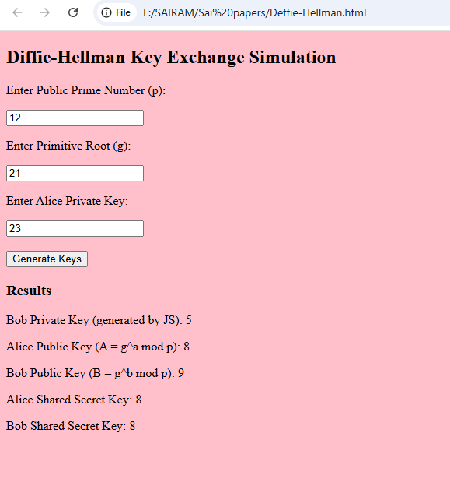
- Calculate the message digest of a text using the SHA-1 algorithm in JAVA.

Program:
import java.security.MessageDigest;
import java.security.NoSuchAlgorithmException;
import java.util.Scanner;

public class SHA1Example {

public static void main(String[] args) {

try {

Scanner sc = new Scanner(System.in);

System.out.print("Enter the message: ");
String message = sc.nextLine();

// Create SHA-1 MessageDigest object
MessageDigest md = MessageDigest.getInstance("SHA-1");

// Convert message to byte array
md.update(message.getBytes());

// Perform hashing
byte[] digest = md.digest();

// Convert byte array into hexadecimal format
StringBuffer hexString = new StringBuffer();

for (int i = 0; i < digest.length; i++) {
hexString.append(Integer.toHexString(0xff & digest[i]));
}

System.out.println("Message Digest (SHA-1): " + hexString.toString());

} catch (NoSuchAlgorithmException e) {
System.out.println("SHA-1 Algorithm not found");
}
}
}

Input & Output:
Enter the message: Hello World
Message Digest (SHA-1): 2ef7bde608ce5404e97d5f042f95f89f1c232871
Text Books:
- Cryptography and Network Security, 3rd Edition Behrouz A Forouzan, Deb deep Mukhopadhyay, McGraw Hill,2015
- Cryptography and Network Security,4th Edition, William Stallings, (6e) Pearson,2006

